Entry & Travel form  Luxembourg  Junior Open 2017 | 

TOURNAMENT DATE
Friday, 21 April 2017 to
Sunday, 23 April 2017

The tournament will start on
Friday at 15.00 hrs.

The last Final will start on
Sunday at 14.00 hrs.

CONTACTS
Tournament Director
Filip Madaric

Tournament Organizer
Frederic Peugeot

Tournament Referee
Arnaud Marinho
VENUE
Top Squash
25, rue de la Gare
L-5218 Sandweiler
Tel: +352 357181

INFO
Sandweiler is a neighbouring town to Luxembourg City, 5km to the east.

Transport will be available to and from the railway station, the airport, the accommodation and the tournament venue.

REGISTRATION CLOSING DATE
Friday, 24 March 2017 - See Entry and Travel forms attached

 | 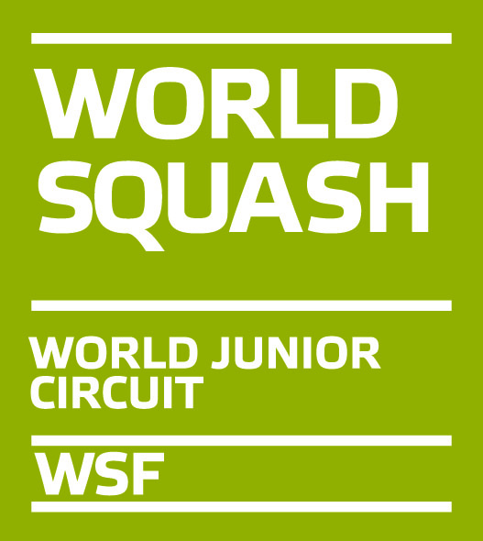 |  | 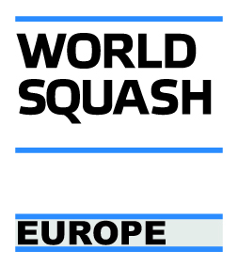
 |  | 

PARTNERS & SPONSORS

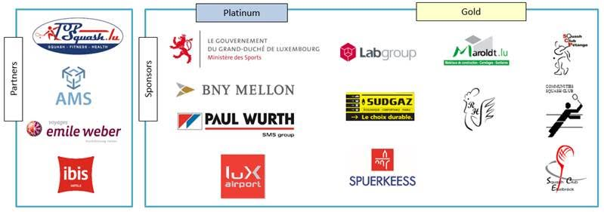

Categories
Boys and Girls under 19, under 17, under 15 and under 13.
The following maximumnumber of players will be accepted in each category:

Girls u13 max. 16
Girls u15 max. 16
Girls u17 max. 16
Girls u19 max. 16

Boys u13 max. 16
Boys u15 max. 32
Boys u17 max. 32
Boys u19 max. 16

Players may only enter one category.

Eligibility
The Luxembourg Junior Open is open to all players under the age of 13, 15, 17 and 19 on 23 April 2017 as appropriate.

SPIN
All players must have an active, paid-for SPIN (Squash Personal Identification Number) to participate - please see www.worldsquash.org/SPIN

Seeding
The seeding will be carried out using the ESF Junior Rankings valid at the closing date and in accordance with the ESF Junior Circuit Guidelines.

Matches & scoring
All matches will be played as best of five games, under the rules of the WSF. PAR scoring to 11 will be used at all tournaments on the ESF Junior Circuit (to 2 clear points). All game scores will be reported in full.

Refereeing
All players will be expected to mark and referee matches.

Ball
DUNLOP PRO

Prizes
There will be prize money in the under 19 boys/girls categories. Trophies will be awarded in all categories.

Insurance
Players enter and play in the tournament at their own risk. Neither the organisers nor the ESF accept any responsibility for injury arising from participating in the event. Players must arrange their own insurance. All players have to wear approved protective eye guards on court.

Entries
All players can register online at www.ljopen.lu or complete the official entry form and send it electronically to via their national federation:

Tournament Director - Filip Madaric
Email 2016ljo@gmail.com
Tel +352 621 394 934
Online form http://www.ljopen.lu

All entries must be made through / endorsed by the relevant national or provincial federation. Any entry not endorsed by a player’s federation will not be accepted. All entries will be acknowledged and published on the tournament website (web-site available from 9th January 2017).

Details of the centre, hotel and travel information will be sent to entrants or their association by e-mail.

Draws
Draws will be circulated to all players or their national associations by e-mail. Times of first matches will be indicated for their players.

All players will be guaranteed a minimum of three matches.

Entry fee/ Tournament Packages

 | Nights** | Meals*** | EUR
Package A - Player - 3 day event*
Package A1 (triple room) | 2 | 5 | 180
Package A2 (double room) | 2 | 5 | 195
Package A3 (single room) | 2 | 5 | 250
Package A4 (triple room) | 3 | 5 | 240
Package A5 (double room) | 3 | 5 | 255
Package A6 (single room) | 3 | 5 | 310
Package A7 | 0 | 5 | 103
Package A8 | 0 | 0 | 51
Package B - Non Player - 3 day event
Package B1 (triple room) | 2 | 5 | 140
Package B2 (double room) | 2 | 5 | 155
Package B3 (single room) | 2 | 5 | 210
Package B4 (triple room) | 3 | 5 | 200
Package B5 (double room) | 3 | 5 | 215
Package B6 (single room) | 3 | 5 | 270
Package B7 | 0 | 5 | 63
Package B8 | 0 | 0 | 0

Note : | Fee includes
* | Tournament Goodie
 | ESF ranking levy fee of 4 EUR
** | Bed & Breakfast Accommodation at Ibis Budget Hotel
 | Only Tournament organisers can make reservations
 | Transportation for arrival/departure and regular shuttles between tournament venue and accommodation
*** | Lunch & dinner on Friday, lunch & dinner on Saturday, lunch on Sunday at venue

Entry fees must be paid by bank transfer, net of bank charges and latest by closing date of entries to:

Bank  Account holder  IBAN  BIC | BCEE Banque et Caisse d’Épargne de l’État Luxembourg  FSL  LU82 0019 1000 7345 6000  BCEELULL
Please mark payment clearly for Luxembourg Junior Squash Open and player’s name and group. Example: Luxembourg Junior Squash Open, Fred Smith, Boys U19
Withdrawal
In the event of a withdrawal, fees will be reimbursed as follows.

- Withdrawal before 7th April: fees will be reimbursed in full less all bank charges.
- Withdrawal between 7th April and 20th April: 50% of fee less all bank charges.
- Withdrawal on or after 21th April: any reimbursement will be at the discretion of the Tournament Organiser.

Transport
Individuals taking package 1 and arriving at Luxembourg City Railway Station or Luxembourg Airport will be met on arrival if the organisers receive travel details by end March.

These individuals leaving after the event will be dropped off at Luxembourg City Railway Station or Luxembourg Airport. See Travel Form below.

Eye guards
All competitors at ESF approved junior tournaments must wear approved protective eye guards, manufactured to an appropriate national safety standard, properly over the eyes at all times during practice and competition play. This includes the knock-up.

It is the responsibility of the player to ensure that the quality of the product is satisfactory for the purpose. Players will not be allowed to compete without this protection. The list of WSF certified eyewear, allowable at the time of participation, can be viewed on the WSF website http://www.worldsquash.org

Filming /Photography
Recording of matches for coaching / performance analysis purposes is acceptable provided the players &/or their parents/coaches do not object."

ESF regulations & penalties
The tournament is part of the ESF Junior Circuit and will be run in accordance with the ESF Junior Guidelines, a copy of which is available on the ESF website www.europeansquash.com. MNAs should make sure that all relevant people (including coaches, managers and players) are aware of the Guidelines and their requirements.

The following penalties will apply, in accordance with the ESF Junior Guidelines, Section E.4.a, E.4.b& E.4.c:

E.4.a) If a player makes a late withdrawal from a tournament (2 days or less before the start date), a doctor’s certificate confirming injury/illness must be provided to avoid penalties. The medical certificate (with a translation in English) must clearly state the player’s name, date of birth and the nature of the illness/injury; the certificate must cover the date of the relevant tournament and must be sent to the ESF office within two days after the final day of the tournament (email: esf@europeansquash.com; fax +44 1424 774879). Any player making a late withdrawal not supported by a medical certificate will receive zero points for the tournament, which will count as one of their 4 best results for the rolling 12 months period and will be taken into account when dividing the points to obtain the ranking average. This penalty will be applied automatically unless the ESF office receives a doctor’s certificate within two days of the final day of the tournament.

If a player commits this offence for a second time within a 12 months period, he/she will be banned from the ESF Junior Circuit for a period of 12 months.

E.4.b) If a player has entered a tournament and fails to turn up, he/she will receive zero ranking points for the tournament. These zero points will count as one of the player’s 4 best results for the rolling 12 months period and will be taken into account when dividing the points to obtain the ranking average. This penalty will be applied automatically.

If a player commits this offence for a second time within a 12 months period, he/she will be banned from the ESF Junior Circuit for a period of 12 months.

E.4.c) If a player fails to play out all scheduled matches for any reason other than illness or injury, he/she will receive zero ranking points for the tournament. Illness or injury must be verified by the tournament director and, if possible, by medical certificate sent to the ESF office within two days of the final day of the tournament. If zero points are awarded, the points will count as one of the player’s 4 best results for the rolling 12 months period and will be taken into account when dividing the points to obtain the ranking average. This penalty will be applied automatically.

If a player commits this offence for a second time within a 12 months period, he/she will be banned from the ESF Junior Circuit for a period of 12 months.

Entry & Travel form
Luxembourg
Junior Open 2017

Entry form
PLEASE NOTE THAT REGISTRATION SHOULD BE CARRIED OUT ON-LINE AT http://www.ljopen.lu

National Association:

Phone: |  | Email:

Coach / Responsible person:
Name:

Phone: |  | Email:

Player (A)
Name | SPIN | Date of birth | Boy / Girl  (B/G) | Event  (u/13,15,17,19) | National ranking | Package  A | T-shirt  Size

Non Player (B)
Name | Package  B | T-shirt  Size
Please return this form by Friday, 24th March 2017, to: Filip Madaric
Email 2016ljo@gmail.com
Tel +352 621 394 934

Tournament Organizer/Co-Director
Frederic Peugeot

Tournament Director  Filip Madaric |  | Tournament Referee  Arnaud Marinho

NB: The tournament website should be up and running by 09th January, 2016

Entry & Travel form
Luxembourg
Junior Open 2017

Travel Form
PLEASE NOTE THAT REGISTRATION SHOULD BE CARRIED OUT ON-LINE AT http://www.ljopen.lu

Arrival
Name | Arrival Place | Date | Time | Flight/Train No.

Departure
Name | Departure Place | Date | Time | Flight/Train No.

Please return this form by Friday, 24th March 2017, to: Filip Madaric
Email 2016ljo@gmail.com
Tel +352 621 394 934

Tournament Organizer/Co-Director
Frederic Peugeot

Tournament Director  Filip Madaric |  |  | Tournament Referee  Arnaud Marinho

